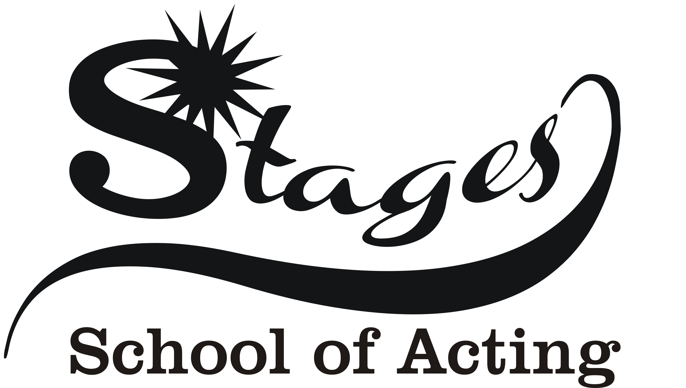
Why Choose a LAMDA examination?

LAMDA offers a wide range of exams. No matter which direction a learner may chose to follow in the future, exams provide the opportunity to nurture natural abilities.

LAMDA exams develop a learner’s ability to:

- read easily, fluently and with good understanding
- expand vocabulary to improve powers of self-expression
- improve confidence in speaking and listening
- memorise and recall information
- engage in constructive informal conversation

These critical skills will enhance the learner’s self-confidence to engage and contribute fully, whether at school, in further education, in work, or in the community: in other words, empowering an individual to fulfil their potential.

LAMDA’s exams are designed to recognise and reward the endeavours of each individual. Learners are awarded an official LAMDA certificate and a medal, where relevant, as well as constructive feedback in a written report to help them advance to the next level. Examiners are experts in their fields who have been trained and standardised by LAMDA to assess learners with objectivity and equality.

The LAMDA examination
At upper infant and primary level, Introductory exams provide an excellent link to literacy requirements for speaking and listening and at primary level, Communication examinations can be used as evidence of success in English.

LAMDA introductory examinations

LAMDA’s solo introductory examinations are designed to introduce learners to creative expression and to the LAMDA examinations framework.
Learners will develop the ability to share a poem and respond to simple questions with confidence, whilst also enhancing their memory and recall skills.
At each stage the learner will memorise and present a set poem to the examiner and have a conversation about:
Stage One - a favourite toy or object that the learner brings with them.
Stage Two -a picture or photograph they bring with them.
Stage Three - a favourite book they bring with them.

Successful learners will receive a LAMDA certificate of their achievement and an examination report from the examiner providing feedback on the assessment. LAMDA Introductory examinations provide a sense of achievement for learners in order to continue their interest in performance and drama.

ACTING

LAMDA Acting examinations are designed to develop the skills necessary to communicate dramatic text to an audience. They help to develop key life skills,
such as understanding and empathy, by allowing learners to engage with different circumstances and/or situations in a practical way. The examinations help to promote creative thinking and exploration, whilst allowing learners to acquire memory skills, spatial awareness, vocal confidence and physical presence. Exploring different characters also allows learners to get to the heart of how feelings and emotions dictate behaviour, encouraging them to become more self-aware.
As with all LAMDA examinations, the development of a clear speaking voice and good body language are an integral part of these exams.
Entry Level, the learner(s) will perform from memory one own choice scene.
At Level 1 and Level 2 the learner(s) will perform from memory one set scene and one own choice scene.

VERSE & PROSE

Using poetry and prose, LAMDA speaking Verse and Prose examinations allow learners to explore literature in an engaging and practical way, and develop solid communication skills.
Developing a good speaking voice is key for these examinations. Learners will recognise how to use their voices in different ways to provoke different reactions. Equally important, memorising a number of pieces encourages self-discipline and focus.
Technically, the learner will develop skills in voice, diction, posture and body language. An in-depth knowledge and appreciation of the literature will also be achieved as they study the text and that will help them communicate each text to the imagined audience in an engaging way.
At each grade, the learner will perform a set verse and/or prose selection and an own choice selection from memory. They will also answer questions about their chosen selections and any other theory required for the grade.

Successful learners will receive a LAMDA certificate of their achievement and an examination report from the examiner providing feedback on the assessment.

LAMDA & UCAS Points:

The University and Colleges Admissions Service (UCAS) is the organisation responsible for managing applications to higher education courses in the UK. Its aim is to help students make informed choices that are right for them – guiding them, as well as their parents and advisers, through the higher education application process.
Applications through UCAS are conducted using the UCAS Tariff. This is a means of allocating points to compare post-16 qualifications used for entry to higher education. It was developed to help learners make sensible application choices and to provide information to universities and colleges about a wide range of qualifications.
LAMDA’s Level 3 recognised qualifications are included in the current UCAS Tariff.

For more information please take a look at LAMDA’s site: https://www.lamda.org.uk/examinations/about-examinations/qualifications-and-credit-framework-qcf-and-european-qualifications

