Dear Parents/Carers,
On Thursday 2nd March it is World Book Day. During the day the children will take part in activities based around books and reading in their lessons.
We are asking children and staff to dress up as story book characters on Thursday 2nd March.
Prizes for the best costumes will be awarded during the day.
World Book Day voucher – All children will be given a £1 World Book Day voucher which they can spend in most reputable book shops.
Half term Challenge
As part of this year’s World Book Day celebrations, Mayfield WANT YOU you to enter our ‘Book in a Box’ competition.
All we ask you to do is recreate a scene, from your favourite story, in a shoebox. We invite you to be as imaginative as possible, and prizes will be ‘up-for-grabs’ for the best entries in each class.
Entries will need to be bought into school no later than Tuesday 28th February.
The ‘winning scenes’, from each class, will be used to create a corridor display for all staff, children and visitors to see.

There are some ideas, pictured below, which we hope will inspire you:
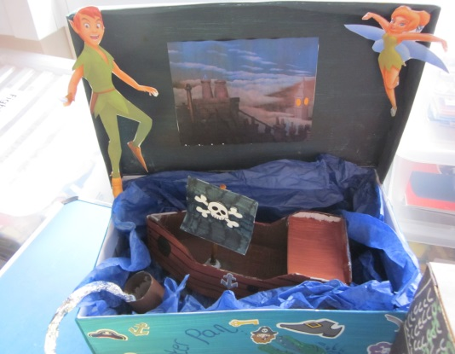
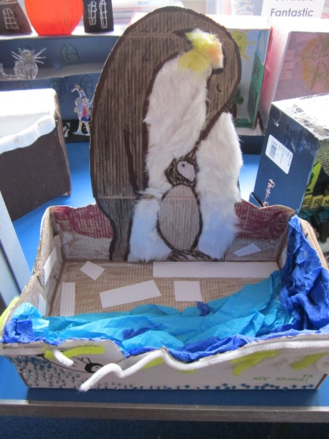
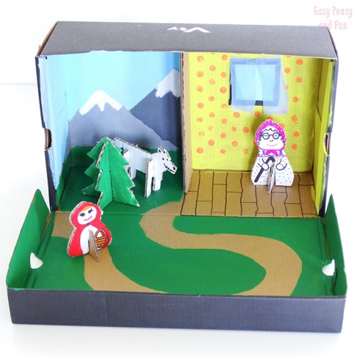

Yours sincerely,

Mrs C Andrews
Head of English

