Meet the teacher Mrs Dhesi – Form I Teaching Assistant
1. How long have you been working at Mayfield?
15 years

2. How many times did you fail your driving test?
I passed first time!

3. What do you like doing at the weekend?
I love spending time with my family. We often go to the cinema.

4. How many jobs have you had before working at Mayfield and where were they?
I have had 5 jobs. They were all in offices.

5. What religion are you?
Sikh

6. How many children do you have?
I have two boys.

7. What is your favourite animal?
Monkey

8. Where has your best holiday been?
In Dubai

9. What is your favourite food?
Chinese food

10. What were your favourite subjects at school?
Art and typing

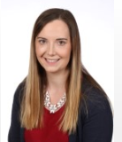

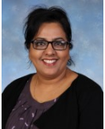

Who would you like me to interview next week?
Please send your questions to Mrs Palmer.

Next Week

On Monday 5th February, children from Upper II and Lower III will again be taking part in the Blue Coat Exhibition at St Matthew’s Church. Our children will being singing Believe by Lin Marsh during the short concert which starts at 1.15pm. All parents are welcome to attend and support the children. There is also an exhibition of work for everyone to enjoy which, this year, celebrates the work of the family.

Children in Form II will be taking part in a Bikeability workshop on Wednesday 9th May.
Upper II children have the opportunity to perform solo pieces during assembly on Wednesday 9th May. Parents of children in Upper II are welcome to attend the performance, which will start at about 9am.
Mrs Anslow will not be teaching the piano on Wednesday 9th May. She will be in school on Friday 11th May to teach all the children she normally teaches on Wednesday.
This week is Friendship Week. The children will be involved in various activities to promote good relations in school.

On Wednesday 9th May, children in Form II and Upper II will have the opportunity to talk to teachers from Secondary Schools in the area in our school hall. Between 6pm and 7pm, all children and their parents are invited to investigate the options available to them for transfer into Year 7. From 7pm, Mr Draper and Mrs Palmer will talk parents of children in Upper II through the many options they have in more detail and offer advice on how to apply for a place at secondary school. This will be in the Art Room.

Children from Lower III will have the opportunity to practise the skills they learned in their bikeability training by going on a more extended cycle ride on Thursday 10th May. Watch out if you are on the roads on Thursday!

There will be workshops to promote friendship for all children on Friday 11th May. Parents are invited to attend a special interactive workshop on Friday in the Hall starting at 2.30pm. Please let the office know if you would like to attend.

Character description of the Dream Giver – Reena (LII)

It was a quiet night. It was 10 o’clock.

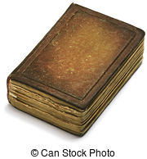
Suddenly, an odd mysterious creature landed on the old, rusty windowsill. It looked like it was from the Tudor times. The creature turned his bright, pale body anticlockwise. He checked an address that shimmered in the moonlight. It read 2655. He took out a brown, little book and wrote something in it.
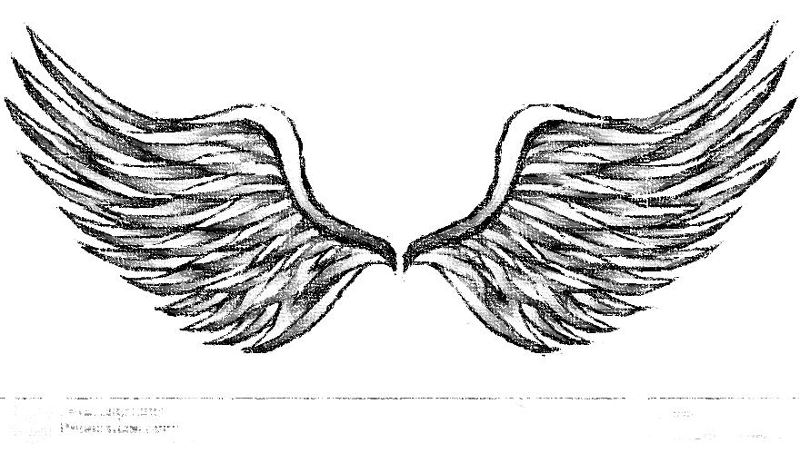
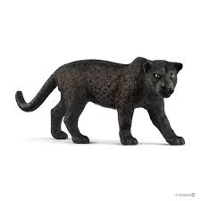
The creature’s see-through, shimmering wings glimmered like stars in the night sky. The creature’s black dull goggles were as dark as a panther. His great head looked at a child and wandered to it. As if he was an ant, he looked at the little child. His eyes glimmered in the street light like two flaming candles.
The creature’s black, dirty staff lay in his wrinkly, pale hands. He blended in with the dark orphanage with his dark clothes. He was a strange creature. His skinny, pale legs were as thin as a washing line without clothes on it. His eyes glittered like pools of fire. The other bits of his eyes looked sticky.
The creature’s nose was like an orange piece, but fatter. It was a peach, pale nose that had bits of dirt on. He had goggles that were really black. You would have thought he was a villain. He had a golden bag that shimmered like stars in the night sky.

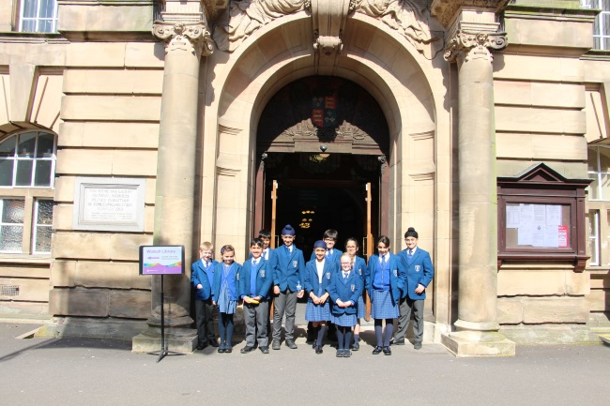
On Tuesday 1st May, the School Council went to see the Mayor. The journey there was quite long as we all had to walk and Mr Watts was unsure of the way.

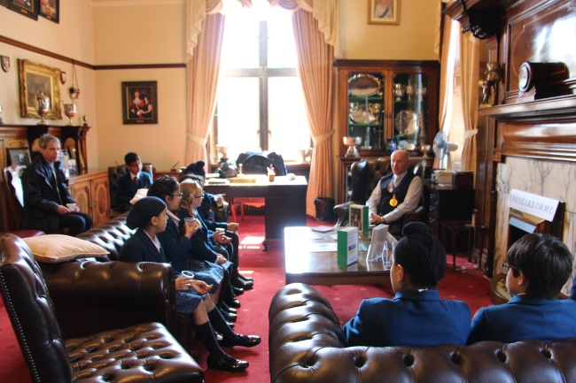
When we got inside, the Mayor was very nice. He asked us questions that were very interesting, such as, what we knew about the Council Wards in Walsall. We found out lots of special stuff that he had to wear or use. He is part of the Conservative party.
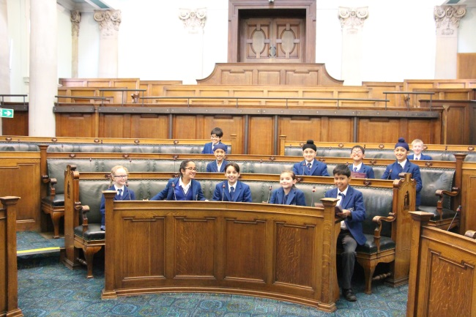
After our conversation we went to the Chambers where the Councillors have their meetings. We got to sit on the chairs and use the microphones. At the end we got stationery that was not available anywhere else in the world!

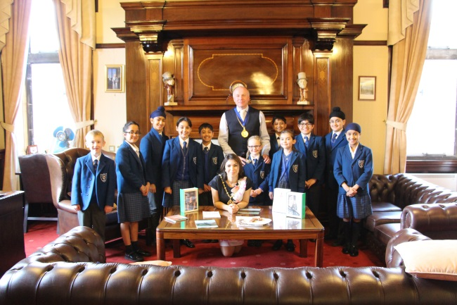
I thought it was a really fun day out and I would like to go again. My favourite part was visiting The Chambers. The Mayor and Mayoress were both very kind.

Serena (UII)

Lower School soloists’ Concert
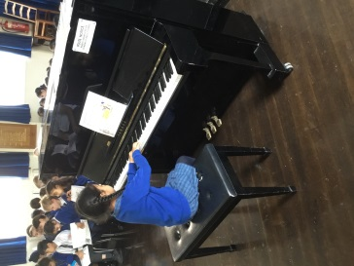
Well done to all the children who performed in the concert on Friday afternoon. Here are photos of just a few of them:

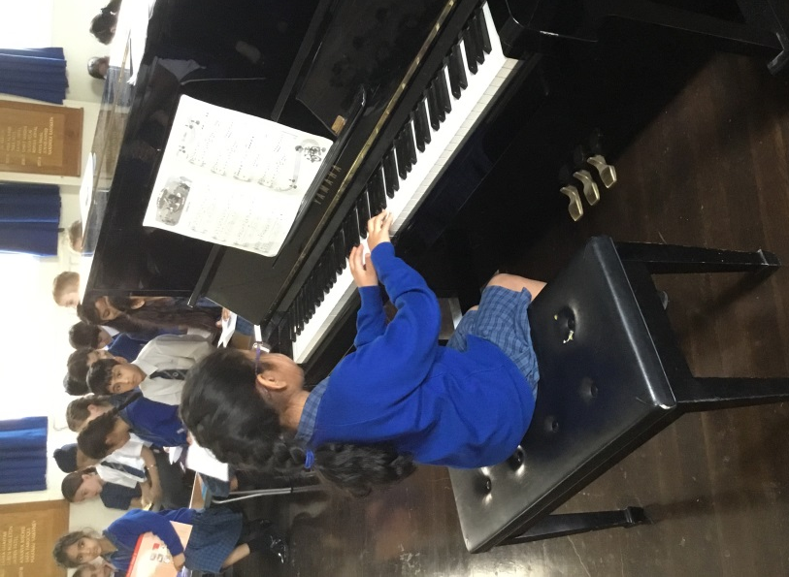
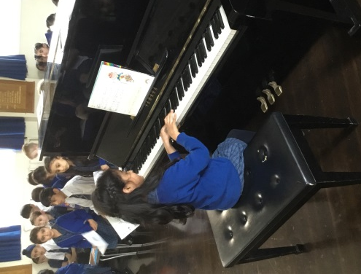

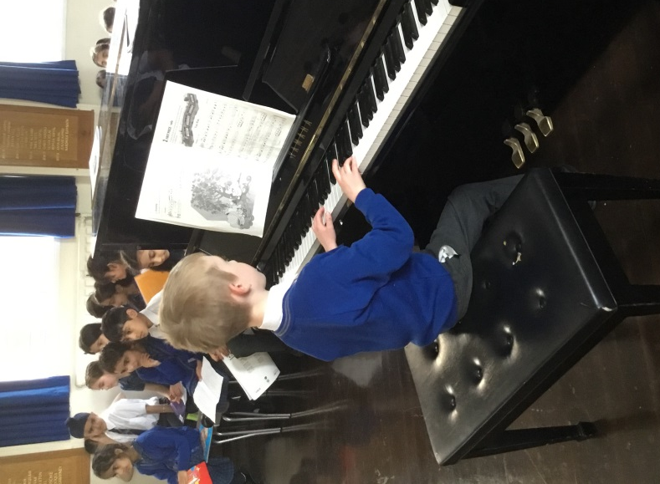

Upper II Assembly
RSPCA

On Thursday 3rd May, children in Upper II gave a thought provoking and, at times, upsetting assembly about the plight of some animals who are treated badly by their owners. The children were reassured to see the good work that the RSPCA do when they rescue mistreated animals, nurse them back to health and find responsible and caring owners who will provide a home for them.
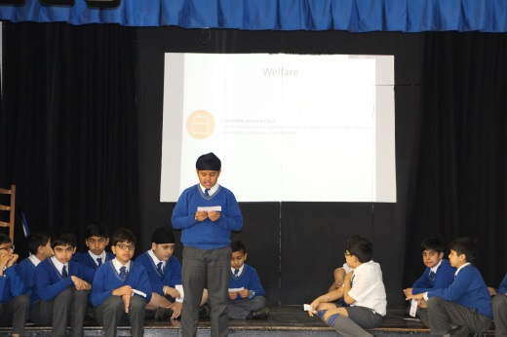
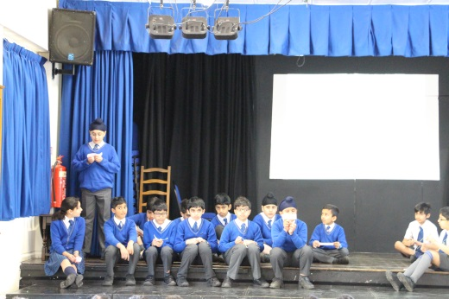
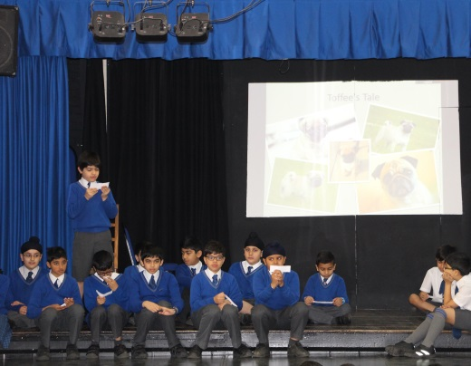

Kindergarten and Nursery
Handwriting Workshop

Miss Roberts held a handwriting presentation for Nursery and Kindergarten parents.

Information was given out about letter formation using RWI and the Nelson Handwriting scheme.

Miss Roberts talked about good practice and common errors among young children developing their handwriting.
